**Introduction**

With the popularity of wear devices, a huge amount of physical-/lifestyle-related data can be easily and continuously collected. An exploration on these data will be helpful for monitoring physical conditions and understanding lifestyle patterns of the users so that personalised approaches can be developed to boost fitness.

This analysis is performed based on FitBit Fitness Tracker Data in Kaggle (ref: https://www.kaggle.com/datasets/arashnic/fitbit). I try to understand the users’ lifestyle and Fitbit usage habit. Moreover, I am also interested in finding out if longer physical activity can increase sleep time.

**1. Data Exploration**

In total, there are activity data of 33 users and sleep data of 24 users. Since 32 users have activity data of at least one week, weekly activity times were summarised based on the 32 users.

Let’s left join the activity data with the sleep data on Id and date, and take a look at the duration of each recorded activity.

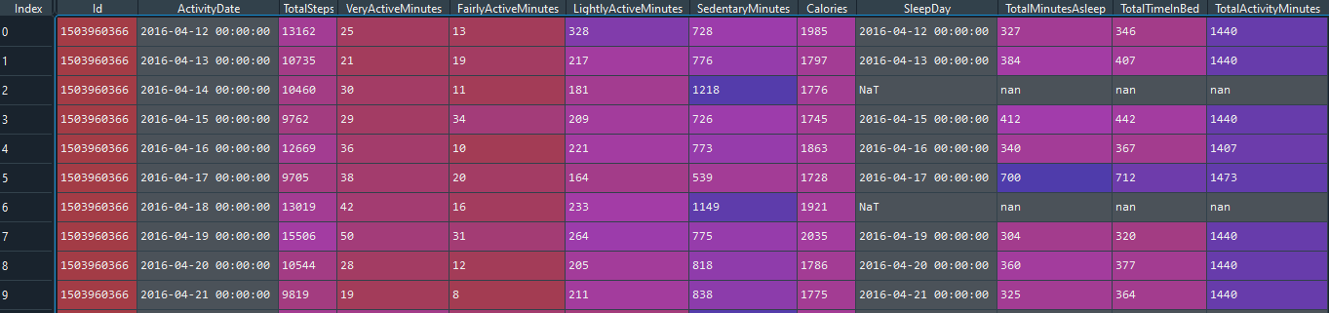

I create a “TotalActivityMinutes” column by summing durations of all activities (i.e., Very active, Fairly active, Lightly active, Sedentary and In bed). From the results, there are two parts that get my attention:

1) For rows with missing value in “TotalTimeInBed”, the “TotalSedentaryMinutes” value is nan. However, if you add the durations of other activities together, you will find that the summed duration is 1440 mins (i.e., 24 hrs). This tells us that in some cases, although total time in bed is not reported, the actual time might still be included in the “SedentaryMinutes”. Therefore, it’s better for us to impute missing value in “TotalTimeInBed” by 0 and combine “SedentaryMinutes” and “TotalTimeInBed” together as a new “TotalSedentaryMinutes” column.

2) In some cases, the “TotalActivityMinutes” are not exactly 1440. It is understandable if a value is below 1440 since the user might need to remove the fitness device in some circumstances like security check, taking exams, BIA evaluation or battery charging. However, for a value above 1440, I cannot figure out a reasonable explanation. Actually, if you take a look at the newly created “TotalActivityMinutes”, you will find that 155 out of 940 observations have values above 1440.

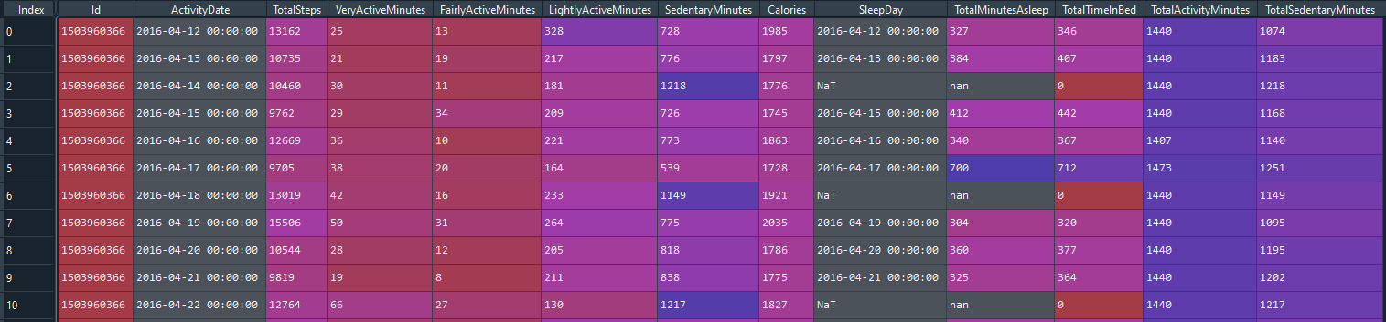

Since the data were directly collected by fitness devices, I assume that the records themselves are correct. There must be some algorithms in defining or aggregating the “SedentaryMinutes” and “TotalTimeInBed” that I fail to figure out. Therefore, I will continue to use original data for analyses on single activity. Meanwhile, in order to present a reliable result, I dropped observations with “TotalActivityMinutes” above 1440 for analyses that combined all activities such as user habit analysis and activity-wise correlation analysis.

**2. Lifestyle Evaluation**

One of the fundamental functions of wearable fitness device is to help users check if they are having a healthy lifestyle. There are several guidelines regarding health maintenance based on the metrics presented in this dataset, e.g., weekly activity, daily steps and daily sleep. According to the physical activity guideline of WHO, an adult is recommended to perform at least 150–300 minutes of moderate-intensity aerobic physical activity or at least 75–150 minutes of vigorous-intensity throughout the week (ref: <https://www.who.int/news-room/fact-sheets/detail/physical-activity>). The US CDC recommends adults to have over 7 hours of sleep (ref: <https://www.cdc.gov/sleep/about_sleep/how_much_sleep.html>) for health maintenance and over 8,000 steps per day are beneficial for lowering risk of all-cause mortality (ref: <https://www.cdc.gov/media/releases/2020/p0324-daily-step-count.html>).

Therefore, let’s first check the proportion of users that lead a suggested healthy lifestyle.

From the aspect of weekly physical activity, let’s assume “fairly active” is “moderate intensive” and “very active” is “vigorous intensive”, then 59% (n = 19) of the users met the suggested level.

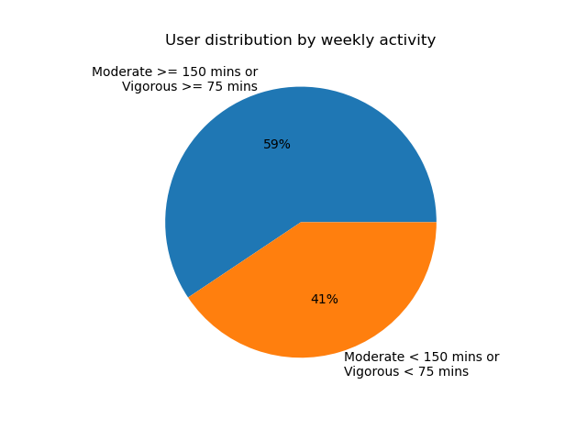

In respect to daily steps, 42% (n=14) of the users met the suggested level.

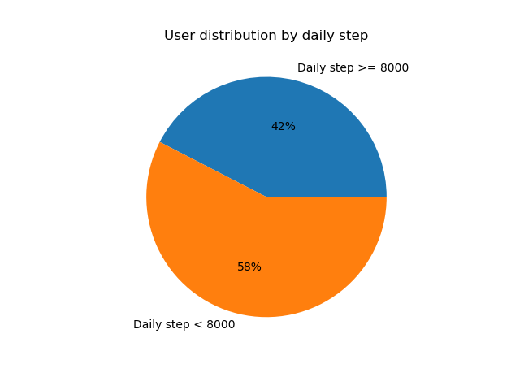

For daily sleep time, 46% (n=11) of the users met the suggested level.

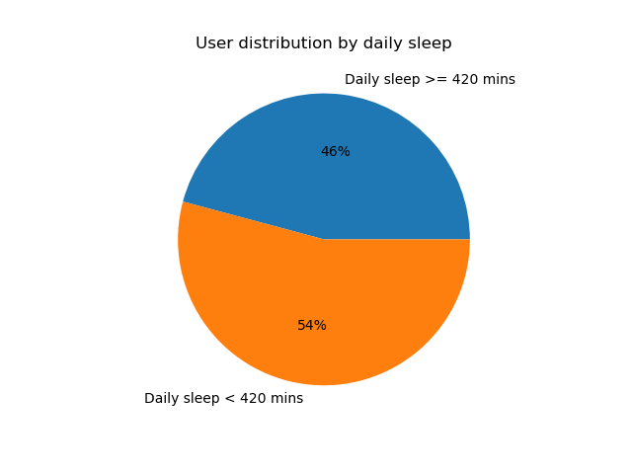

We can also generate personalised feedback report using the lifestyle_feedback() function in src/feedback.py

**3. User Habit**

ATTENTION: As discussed before, this part of analysis is based on users with “TotalActivityMinutes” no greater than 1440 mins.

The filtered dataset covers a timespan of 31 days (from 2016-04-12 to 2016-05-12). To check the usage of Fitbit by each user, we can call the usage_bar_chart () function in src/visualization.py.

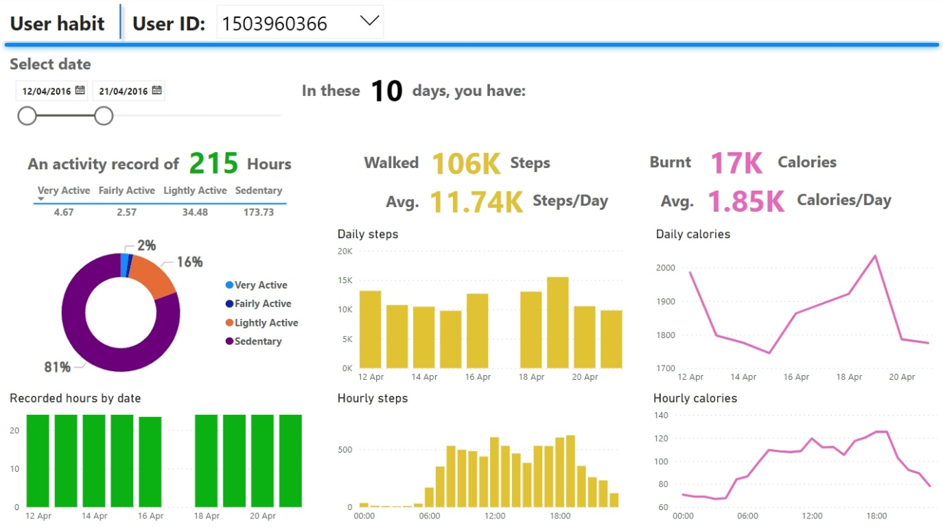Meanwhile, I create a PowerBI file (UserDescription.pbix) to present a more intuitive and interactive visualisation. We can easily check the Fitbit usage of a user over selected time periods and look into the data of a single day by highlighting the corresponding bar.

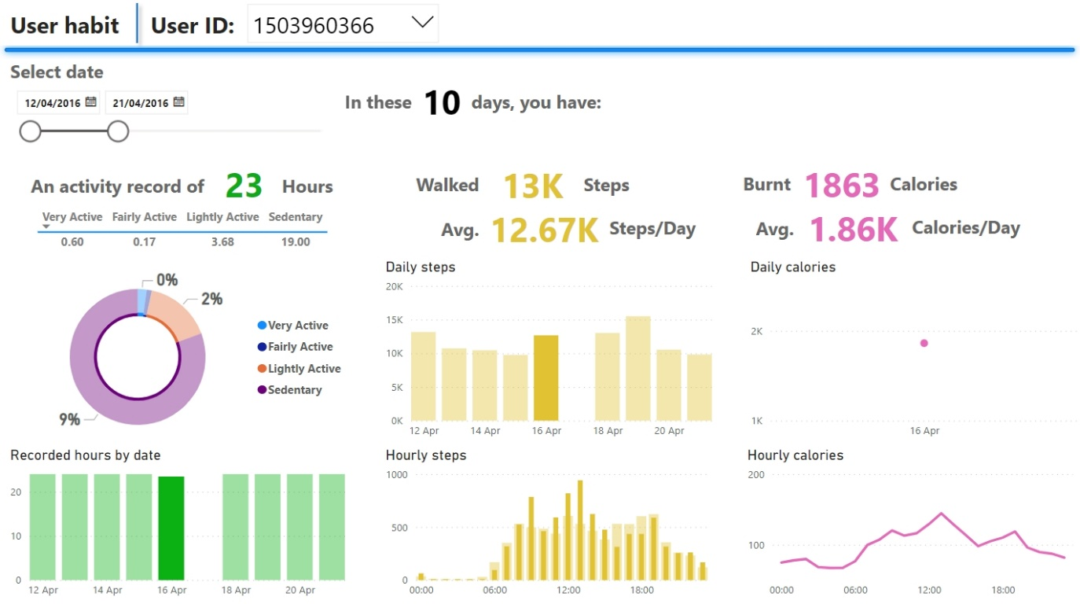

Now comes the question: are people who often use Fitbit physically more active than those who occasionally wear it? Let me first present four plots:

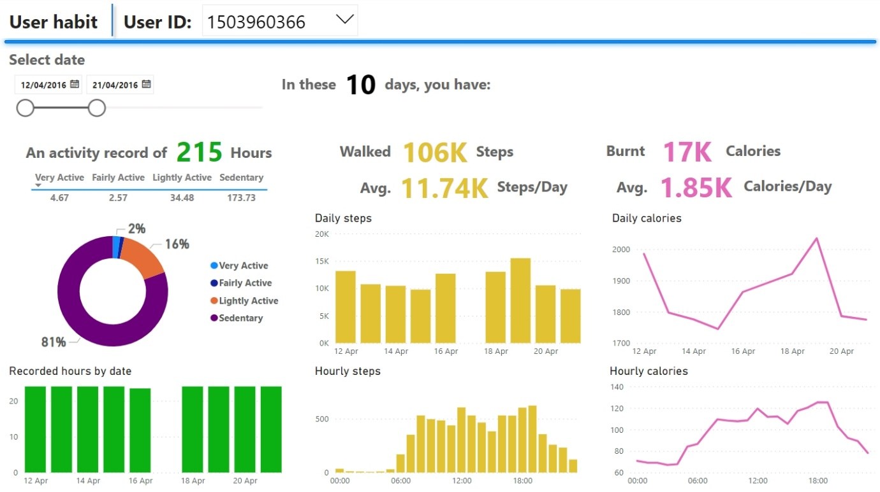

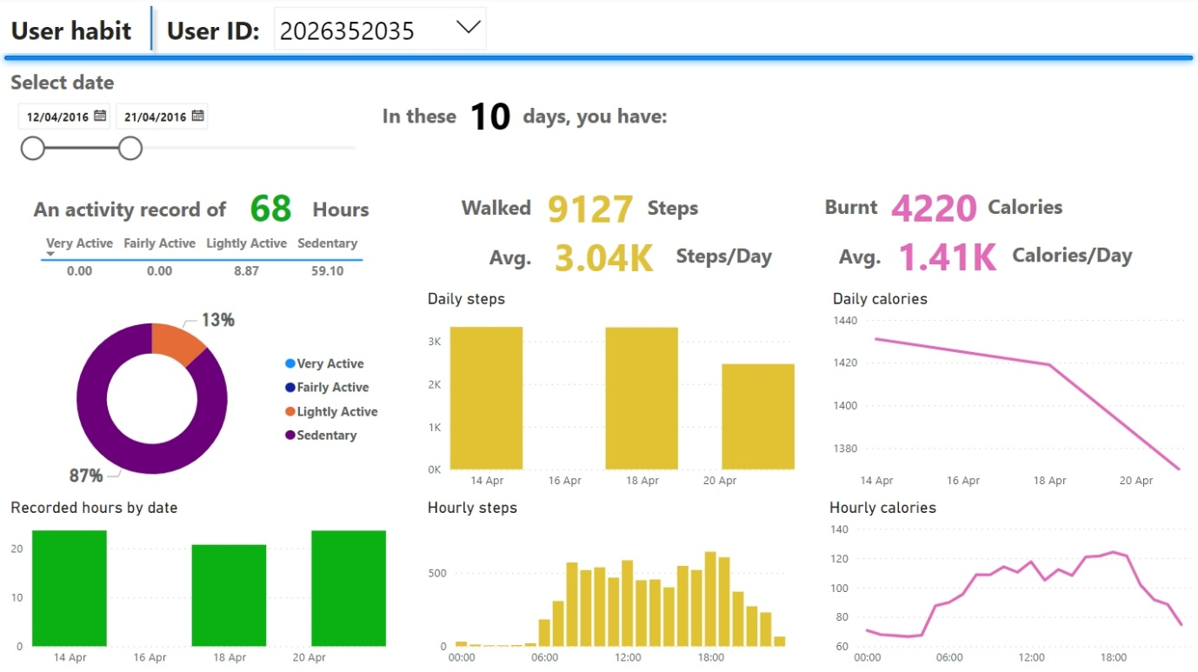

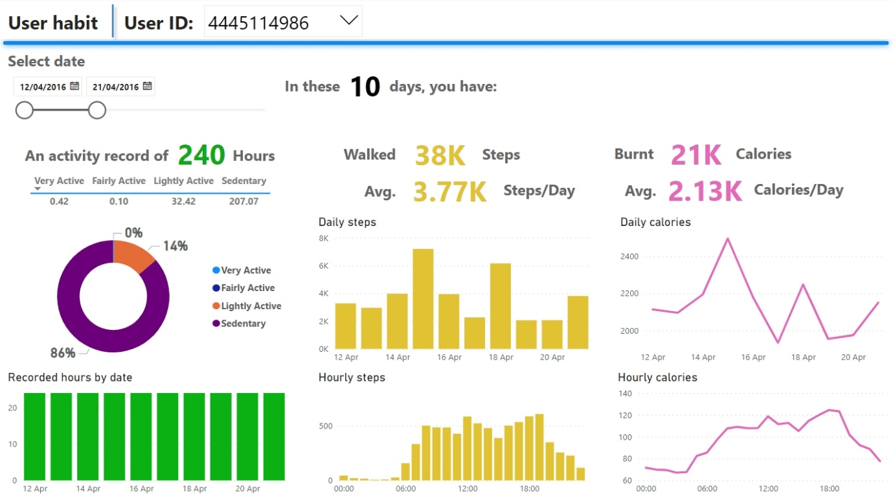

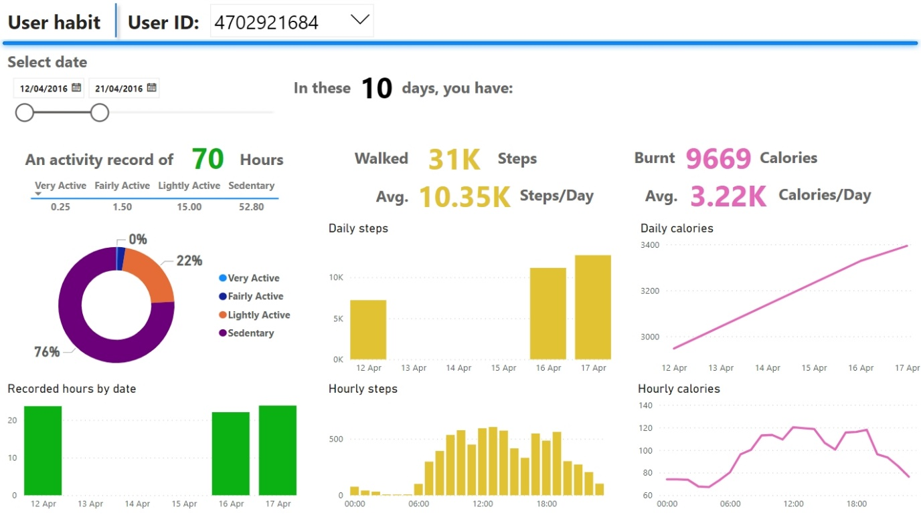

From the four plots above, it is a bit hard to tell if the frequency of device usage is related to daily steps or calories as we can see that users with a long device usage can still have fewer steps and calories than those who do not wear it so often. Yet, I would like to see if there is any trend in general.

To analyse the device usage, I decide to use two metrics: wearing days in the 31 days timespan and percentage of fully recorded days among wearing days. Since Fitbits take around 2 hours to be fully charged (ref:  [https://help.fitbit.com/manuals/charge_5/Content/manuals/Topics/Set%20Up/Charge%20Device.htm](https://jaysonmag.com/how-to-charge-a-fitbit-watch/#:~:text=A%20Fitbit%20should%20take%20from%201%20to%202,will%20run%20time%20reduces%20to%20approximately%2010%20hours.) ). I assume that a day with wearing time no less than 22 hours as being fully recorded.

From the scatter matrix, we cannot tell any clear linear relation between device usage and daily steps or calory expenditure.

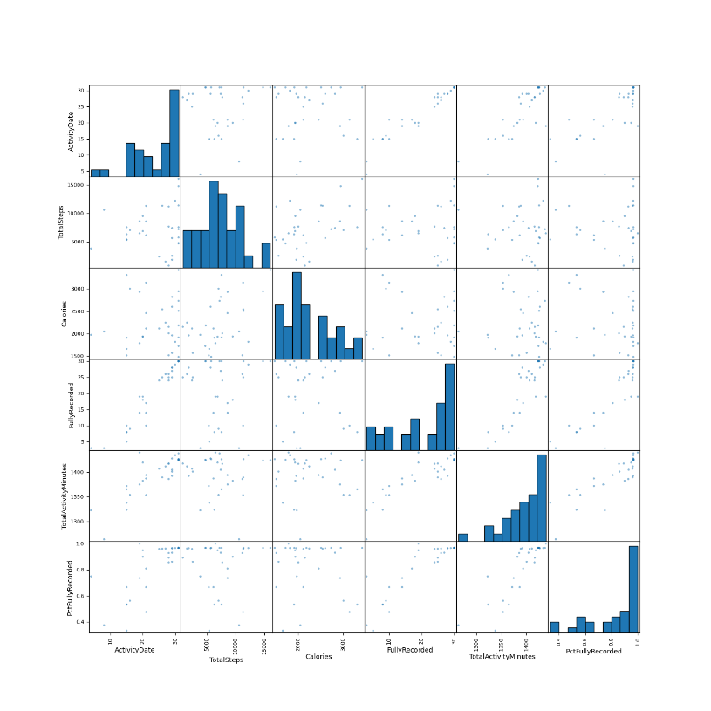

Correlation analyses further confirm that no significant correlation exits. Therefore, we cannot tell the activity level of a user by simple looking at the device usage habit.

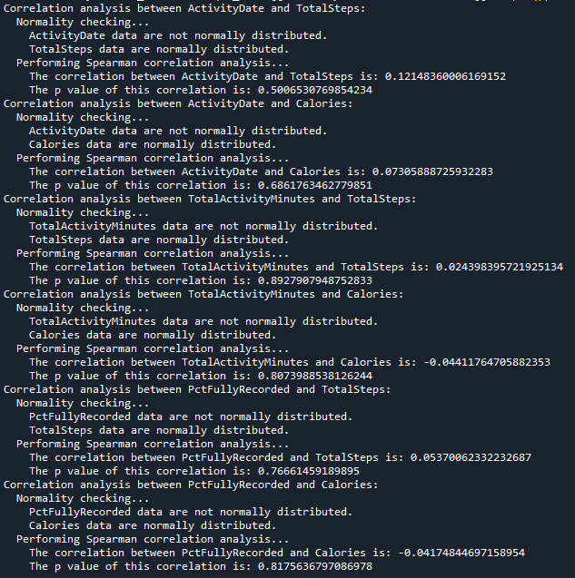

**4. Activity and Sleep Analysis**

Now comes the last question: are physical activity and daily steps related to sleep time? Before answering this question, let’s take a peek at the correlations between these variables by a scatter matrix.

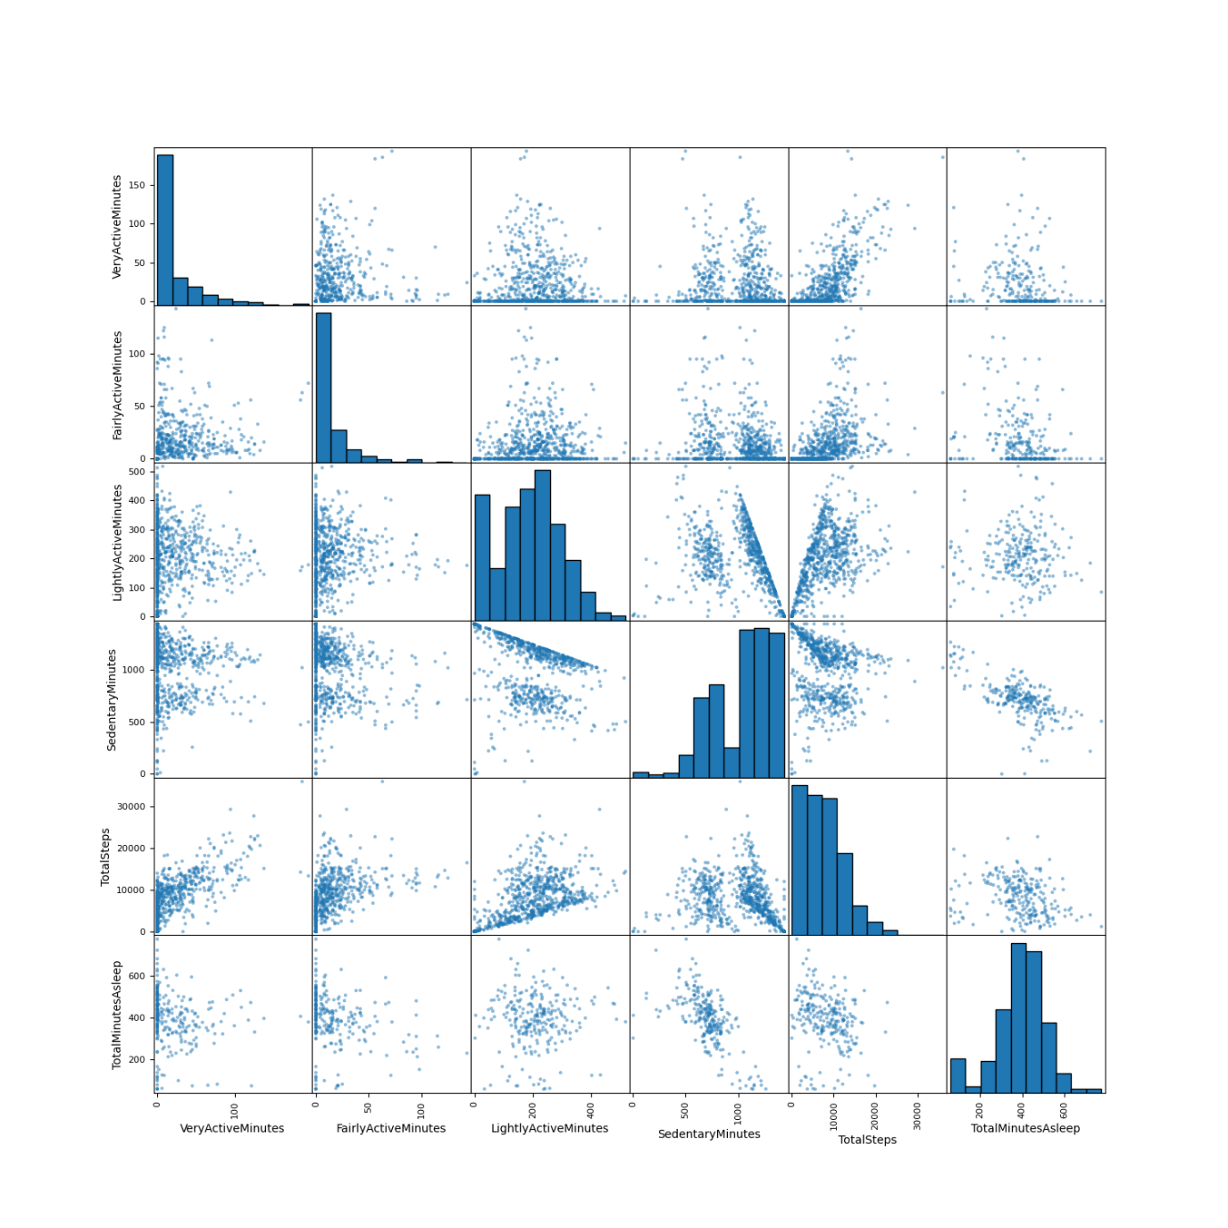

From the graph, we can see that there are not clear linear correlations between sleep time and other variables, except for “sedentary minutes”, in which we can clear tell a negative correlation between these two variables.

Now let’s analyse the linear associations between sleep time and other variables one by one using the ana_correlation() function in src/analysis.py. The function first performs a normality test to check if the input data are normally distributed, if so, Pearson correlation analysis is performed, otherwise, Spearman correlation analysis is used. Results of the current data are presented as follows:

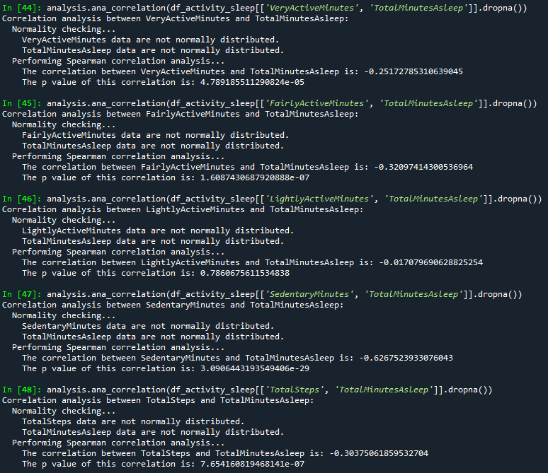

As presented in the results, weak negative associations are found between sleep time and three variables: very active minutes, fair active minutes and daily steps. Moderate negative association is found between sleep time and sedentary minutes. Such moderate association is not a surprise considering the mystery between time in bed and sedentary minutes discussed at the beginning of this report.

**5. Summary**

In summary, we have:

1) evaluated the lifestyle of the users based on thresholds recommended by health organisations, we can nudge users to be more active if they fail to meet these thresholds.

2) created an interactive dashboard to present user habit. It will be helpful for us to understand the activity pattern of the user and give personalised suggestions according to day of week (not presented but created in the PowerBI file as it is based on the unfiltered dataset) and hour. Additionally, for users who occasionally wear the device, we can encourage them to wear the device more often by showing them the importance of continuous monitoring on physical status and lifestyle patterns in health maintenance. For users who often use the device, we can give them more challenging tasks to help them stay active.

3) not found any significant linear correlation between device usage and physical activity level. Weak associations are found between sleep time and three activity variables: very active minutes, fair active minutes and daily steps. However, we should treat these findings with caution due to the limited sample size and the weird negative association.